3ɸ CONVERTER CONTROLLED DC DRIVES

**Three-phase full-wave Controlled Rectifier with highly inductive load (Continuous load current)**  
  
*Average Load/Output Voltage*  
  
{V_0} = \frac{{3\sqrt 3 {V_m}}}{\pi }\cos \alpha   
  
{V_0} = \frac{{3\sqrt 6 V}}{\pi }\cos \alpha   
  
  
  
*Vm peak phase voltage*  
  
*V rms phase voltage*  
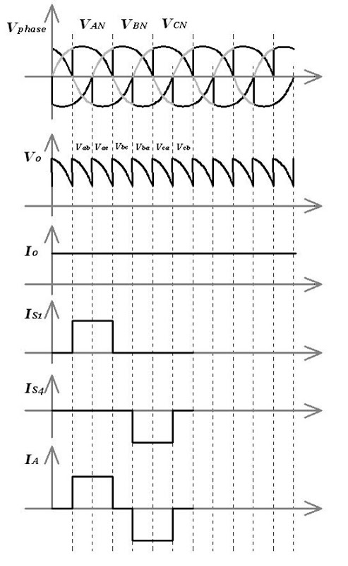  
  
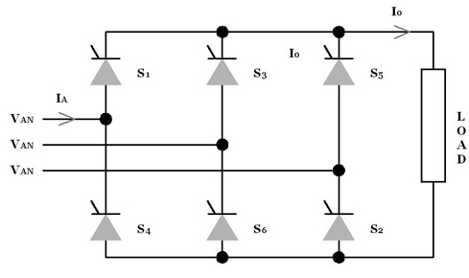  
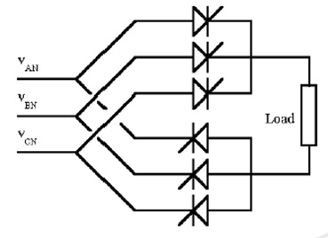  
**Three-phase full-wave Controlled Rectifier with highly inductive load**

Voltage and current waveforms of a three-phase full converter with a highly inductive load is shown in figure. This converter provides two quadrant operation and thyristors are fired at an interval of π/3 degrees. Since thyristors are fired every 60°, the frequency of the output ripple voltage is six times the frequency of the supply voltage. At ωt = π /6 + α, thyristor S6 is already conducting and thyristor S1 is turned on. For the interval ωt of π/6 to π/2 thyristors S1 and S6conduct, and line to line voltage vab appears across the load. At ωt = π /2 + α, thyristor S2 is turned on and thyristor S6 is turned off due to natural commutation. This occurs because when thyristor S2 is turned on, the line to line voltage across thyristor S6 is the positive voltage vbcfrom cathode to anode which reverse biases thyristor S6. During the interval ωt of (π /2 + α) (5 π /6 + α), thyristors S1 and S2 conduct and line to line voltage appears across the load. The firing sequence of the thyristors is: 12, 23, 34, 45, 56 and 61.

The average output voltage is given by

{V_{dc}} = \frac{{3\sqrt 3 {V_m}}}{\pi }\cos \alpha 

The maximum output dc voltage is given by

{V_{dm}} = \frac{{3\sqrt 3 {V_m}}}{\pi }

The rms output voltage is given by

**Three-phase Converter Output Characteristics for continuous load current (Full Converter)**

[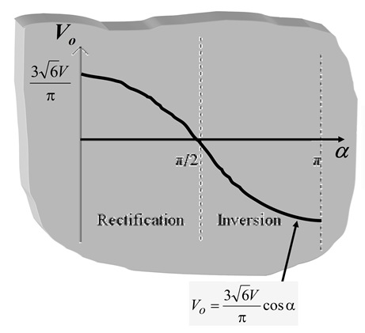](http://lh6.ggpht.com/-wdCNQneWyY4/Tf_W_Hja2WI/AAAAAAAABfA/0gTmuHWesLk/s1600-h/264.jpg)  
For fully controlled rectifier, The DC Motor operates in two modes.   
Rectification [As Motoring] 

*V0 = positive   
Ea = Positive   
Io= positive   
Power Flow (+ve) from input AC to DC machine*

Inversion [As Regenerative Braking] 

*V0 = negative   
Ea = negative   
Io= positive   
Power Flow (-ve) from DC machine to AC supply*

**Thyristor based Rectifiers (3-phase)**[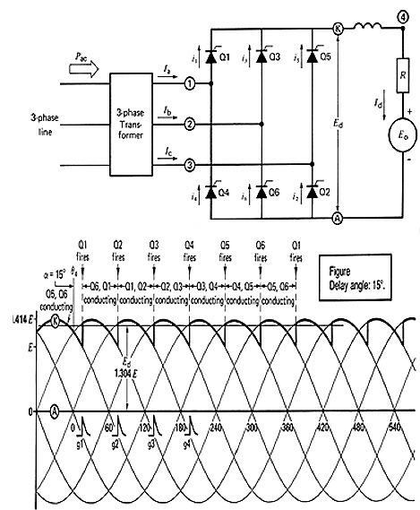](http://lh3.ggpht.com/-d0ulEOPAk3M/Tf_XFqvx6tI/AAAAAAAABfI/U7ajZmg25sg/s1600-h/2712.jpg)[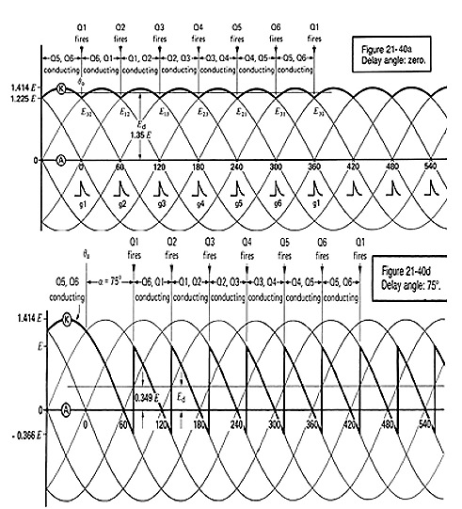](http://lh6.ggpht.com/-7smWRv_XKbs/Tf_XM1r3PXI/AAAAAAAABfQ/0cjcMBjDXtc/s1600-h/285.jpg)

Ed becomes smaller as α increases, but still each thyristor conducts 120 deg. Power flow is from AC side to DC side. Id=(Ed-E0)/R

**Thyristor based Line Commutated Inverter (3-phase)**

[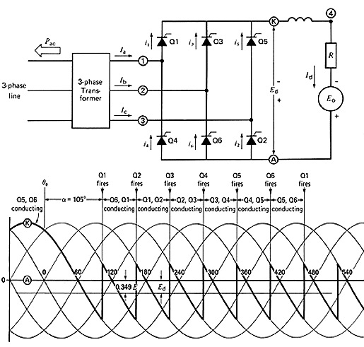](http://lh5.ggpht.com/-92mqLKpf7Vs/Tf_XVnqvMwI/AAAAAAAABfY/PeSf56RTrNw/s1600-h/295.jpg)  
Id=(Eo-Ed)/R, real power flow is from DC to AC side, Polarity of Ed is reversed.  
**Triggering range:**

Rectifier 15°-90°, inverter: 90°-165°. Thyristor may misfire for α less than 15° (def. 8°) for sudden change in line voltage and hence discontinuity in output current. If we go beyond 165°, the inverter may lose its ability to switch from one thyristor to the next. As a result currents build up very quickly until the CB trips. For safety margin max α is 150°.

Chopper Control of Separately Excited DC Motor

The chopper converts the fixed DC voltage to variable DC voltage. Self-commutated devices (directly on or off devices via gate) like MOSFET, IGBT, power transistors, GTO and IGCT are used for making choppers because they can be commutated by low power control signal and do not need commutation circuit.

The chopper was operated at high frequency due to which it upgrade the motor performances by decreasing the ripple and removing the discontinuous conduction. The most important feature of chopper control is that the regenerative braking is carried out at very low generating speed when the drive is fed from a fixed voltage to low DC voltage.

## Motoring Control

The transistor chopper controlled separately excited DC motor is shown in the figure below. The transistor Tr is operated periodically with period Tr and remains open for a duration Ton.The waveforms of motor terminal voltage and armature current are shown in the figure below. During on the motor terminal voltage is V and operation of the motor is described as

[equation-1](https://circuitglobe.com/wp-content/uploads/2016/12/equation-1.jpg)

[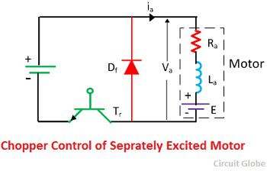](https://circuitglobe.com/wp-content/uploads/2016/12/chopper-control-of-separately-excited-motor.jpg)In this interval, the armature current raises from ia1 to ia2. This interval is called duty interval because the motor is directly connected to the source.

At t = ton, Tr is turned off. Motor current freewheels through diode Df and motor terminal voltage is zero during interval**ton≤ t ≤ T.** Motor operation during this interval is known as freewheeling interval and is described by

[equation-2](https://circuitglobe.com/wp-content/uploads/2016/12/equation-2.jpg)

Motor current decreases from ia2 to ia1 during this interval.The ratio of duty interval ton to chopper period T is called duty cycle.

[regenrative-braking](https://circuitglobe.com/wp-content/uploads/2016/12/equation-33.jpg)

### Regenerative Braking

Chopper for regenerative braking operation is shown in the figure below. The transistor Tr is operated periodically with a period T and on-period of ton. The waveform of motor terminal voltage va and armature current ia for continuous conduction is shown in the figure below. The external inductance is added to increase the value of La. When the transistor is on, ia increased from ia1 to ia2.

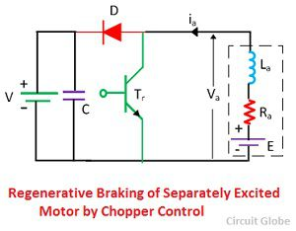

The mechanical energy is converted into electrical energy by the motor, now working as a generator, partly increased the stored magnetic energy in the armature circuit inductance and the remainder is dissipated in armature and transistors.

[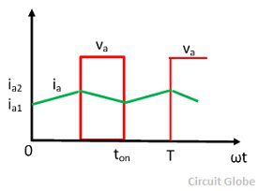](https://circuitglobe.com/wp-content/uploads/2016/12/regenrative-braking.jpg)

When the transistor is turned off, the armature current flows through diode D and the source V and reduces from ia2 to ia1. The stored electromagnetic energy and the energy supplied by the machine are fed to the source. The interval0  ≤ t  ≤t**on** is called energy storage interval and the interval ton ≤ t ≤ T called the duty interval.

### Forward Motoring and Braking Control

The forward motoring operation of the chopper is obtained by the transistor Tr1with the diode D1.The transistor Tr2 and diode D2 provide the control for forward regenerative braking operation.

[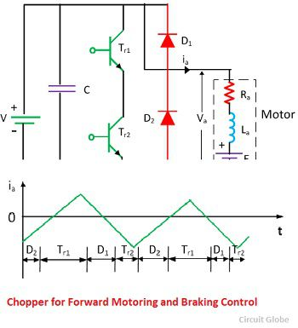](https://circuitglobe.com/wp-content/uploads/2016/12/chopper-for-forward-and-braking-control.jpg)

For the motoring operation, transistor Tr1 is controlled, and for braking operation, the transistor Tr2 is controlled. Shifting of control from Tr1 to Tr2shift the operation from motoring to braking and vice versa.

### Dynamic Control

The dynamic braking circuit and its waveform are shown in the figure below. During the interval between 0 ≤ t ≤Ton, ia increases from ia1 to ia2. The part of the energy is stored in inductance and rest is dissipated in Ra and TR.

[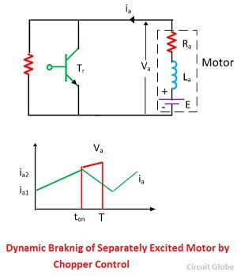](https://circuitglobe.com/wp-content/uploads/2016/12/dynamic-braking-of-separatly-excited-DC-motor.jpg)During the interval **Ton≤ t ≤ T**, ia decreases from ia2 to ia1.The energies generated and stored in inductances are dissipated in braking resistance RB, Raand diode D.Transistor Tr control the magnitude of energy dissipated in RB and therefore control its effective value.